ITEM DETAILS
Name of Item | Victorian Terrace
Other Name/s  Former Name/s | 65 Albion Street, Waverley
Item type | Built
Item group | Residential Buildings (private)
Item category | Villa
Area, Group, or Collection Name | Unknown
Street number | 65
Street name | Albion Street
Suburb/town | Waverley |  |  |  |  | Postcode |  |  | 2024
Local Government Area/s | Waverley
Property description | Lot 1 DP 72866, Lot 1 DP 68420
Location - Lat/long | Latitude | -33.904633 |  | Longitude | 151.253643
Location - AMG (if no street address) | Zone |  |  | Easting |  |  |  | Northing
Owner | Private
Current use | Residential
Former Use | Residential
Statement of significance | 65-67 Albion Street, Waverley, is a pair of two-storey freestanding Filigree Victorian terrace houses that are distinctive and prominently located on the corner location of Macpherson Street & Albion Street, which represents the original subdivision pattern of Terminus Estate subdivision. It represents the c1885 subdivision of the Terminus Estate, which reflects the improvement in public transport following the 1881 extension of the tram to Charing Cross and demonstrates the speculative development of freestanding Victorian terraces, which reflect the optimism following the 1890 depression in the lead up to the Federation period.  65-67 Albion Street, Waverley demonstrates domestic life in the late Victorian period in Waverley.  It is a rare example of a fine and intact pair of two-storey freestanding Filigree Victorian terrace houses in Waverley, despite being well represented in other local government areas.
Level of Significance | National |  | State |  |  |  | Local

DESCRIPTION
Designer

Builder/ maker | John Allin
Physical Description | 65-67 Albion Street, Waverley is a pair of two-storey freestanding terrace houses that date from the late Victorian period, a key period of significance, and reflects the subdivision of the Terminus Estate, c1885.  The buildings display features of the Victorian Filigree style including two-storey verandah screens façade, decorative cast iron balustrade, fringe, brackets and classical slander posts to verandahs, classical motifs to fin walls, timber double-hung windows to ground floor, timber French doors and fanlight to upper floor, prominent chimneys, stucco wall finish and decorative label moulds and sill brackets.  The buildings are setback 6 metres from the street on rectangular sites approximately 9 metres wide, that reflects the original Terminus Estate subdivision pattern in a suburban setting that has partially lost its historic context.  The site has a palisade rendered brick fence at 67 Albion Street which compliments the setting of the place, and a timber paling at 65 Albion Street approximately 1.5 metres high, which detracts from the setting. No. 67 Albion Street features a garage accessed from the rear lane and which is of a later date. The sites are large and landscaped and feature a path, steps, lawn, hedging, exotic vegetation and provide an appropriate setting for the two residences. The buildings are in good condition and highly intact.  Elements impacting upon the integrity of the site include fencing to No. 65 Albion Street, and replacement of the roof finish.
Physical condition  and  Archaeological potential | The building appears to be in good condition
Construction years | Start year | 1884 | Finish year | 1884 | Circa
Modifications and dates | 1913 title shows the footprint of No. 67.  1943 aerial photograph corresponds with the 1892 survey showing 65-67 in a group of 4.

HISTORY
Historical notes | Crown grant September 1856 to William Roberts. 65-67 Albion Street, Waverley was part of Lots 8, 9 and 10 of Section B of the Terminus Estate (Terminus Estate Waverley, SLNSW). Trams ran past the site down Albion Street from the old Tram Terminus to Randwick, and later branched off Macpherson Street to the new Waverley Terminus. (Wycombe Estate, Z/SP/W6/202, SLNSW). Builder John Allin purchased land in May 1884. In March 1885, he advertised “For Sale – two superior villa residences healthy locality, best position in Waverley, large rooms, dining and drawing rooms, folding doors, 5 bedrooms, kitchen, scullery, bathroom, halls, verandahs, balconies, every convenience. Apply J. Allin, opposite Clergy Daughters Tram Terminus.” (SMH 14 Mar 1885 p.7). It is likely that the building was constructed by Allin in 1884-1885. The 1892 survey shows the pair constructed, the middle two in a group of four freestanding terrace houses. (Waverley Sec 15 1892, SLNSW). The land was purchased by Meyrick Fitzpatrick Rainsford, retired life assurance accountant of Waverley c.1889. He made an application to bring the land under the Provisions of Real Property Act in 1913 (Primary Application 18420). The diagram attached to the 1913 title shows the footprint of No. 67. In 1920, Marie, Ida and Mabel Rainsford with Mabel Gainford brought No. 65 under Real Property Act Provisions (Primary Application No 22866). The Primary Application sketches note the name ‘Arizona’ at No. 65. No. 67 was leased to Gerald Benjamin, warehouseman, in 1912. In 1939, the site of No. 67 was sold to Henry McGrath, carpenter of Waverley. The 1943 aerial photograph corresponds with the 1892 survey showing 65-67 in a group of 4, prior to the extension of Macpherson Street between Carrington and Albion Streets. In 1957, Lance Davis of Waverley, real estate agent, purchased the site, selling the following year to Carl Peter John Kristofferson, a school teacher of Waverley. In 1988, No. 67 was purchased by Charles Wheeler and Deborah Donnelley. (Certificate of Title Vol 2367 fol 7).

THEMES
National  historical theme | 3 Developing local, regional and national economies  4 Building settlements, towns and cities  8 Developing Australia’s Cultural Life
State  historical theme | Transport  Land tenure  Accommodation  Domestic life
Local  historical theme | Traffic and Transport  Speculation and Subdivision

Assessment
A: Historical Significance | 65-67 Albion Street, Waverley, has historic significance at a local level as it represents the c1885 subdivision of the Terminus Estate, which reflects the improvement in public transport following the 1881 extension of the tram to Charing Cross.  65-67 Albion Street, Waverley, has historical significance at a local level as it demonstrates the speculative development of freestanding Victorian terraces, which reflect the optimism following the 1890 depression in the lead up to the Federation period.  65-67 Albion Street, Waverley, has historical significance at a local level as it is able to demonstrate domestic life in the late Victorian period in Waverley.
B: Associative | To date no historic association significance has been identified.
C: Aesthetic significance | 65-67 Albion Street, Waverley, has aesthetic significance at a local level as pair of two-storey freestanding Filigree Victorian terrace houses that are distinctive, and prominently located on the corner location of Macpherson Street & Albion Street, which represents the original subdivision pattern of Terminus Estate subdivision.  They are a fine and intact example of a pair of two-storey freestanding Filigree Victorian terrace houses which feature decorative cast iron balustrade, classical motifs to fin walls and decorative label mound and sill brackets.
D: Social significance | To date research indicates that no social, cultural, and spiritual significance has been identified.
e) Technical/  Research significance | To date research indicates that no research/technical significance has been identified.
f) Rarity | 65-67 Albion Street, Waverley, have rarity significance at a local level as they are a rare example of a fine and intact pair of two-storey freestanding Filigree Victorian terrace houses in Waverley, despite being well represented in other local government areas.
g) Representative-ness | 65-67 Albion Street, Waverley, has representative significance at a local level as it is a fine and intact example of a pair of two-storey freestanding Filigree Victorian terrace houses that represent the early development of the Terminus Estate.
Integrity | The building is highly intact.
Recommended Management | Elements impacting upon the integrity of the site include fencing to No. 65 Albion Street, and replacement of the roof finish.

HERITAGE LISTINGS
Heritage listing/s | Draft Waverley LEP 2012

INFORMATION SOURCES
Type | Author/Client | Title | Year | Repository
 | Waverley Council | Waverley Heritage Policy | 2007
 | Waverley Council | Waverley Heritage Study | 1993
 | Perumal Murphy Pty Ltd | Waverley Heritage Study | 1990
 |  | Wycombe Estate, Z/SP/W6/202 |  | State Library NSW
Newspaper article | The Sydney Morning Herald | 14 Mar 1885 p.7 | 1885 | National Library Australia
 |  | Terminus Estate Waverley |  | State Library NSW
 |  | Waverley, Sec 15 1892 | 1892 | State Library NSW
 |  | Primary Application 18420 |  | NSW Land Registry Services
 |  | Primary Application 22866 |  | NSW Land Registry Services
 |  | Certificate of Title, Vol 2367 fol 7 |  | NSW Land Registry Services.

RECOMMENDATIONS
Recommendations

SOURCE OF THIS INFORMATION
Name of study or report | Heritage Policy by Waverley Council reviewed by Architectural Projects 2023 |  | Year of study or report
Item number in study or report

Author of study or report
Inspected by
NSW Heritage Manual guidelines used? |  |  |  | Yes |  | No
This form completed by |  |  |  | Date

IMAGES

Image caption  65 Albion St  67 Albion St | 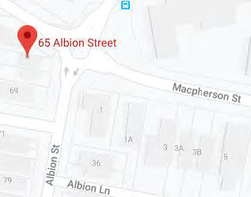  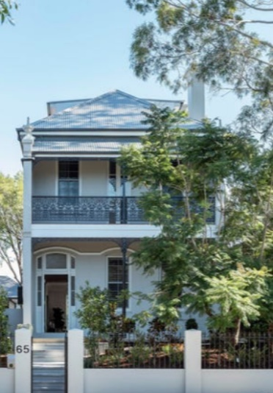  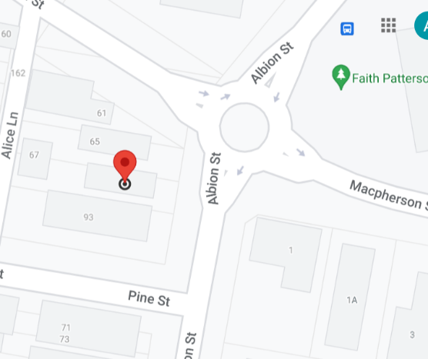  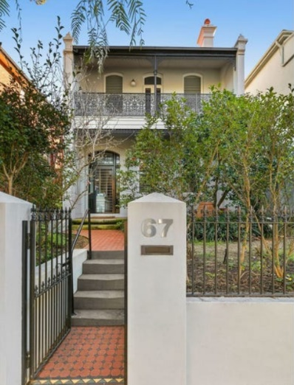
Image year |  | Image by | Google Maps, Domain | Image copyright holder

Image caption | 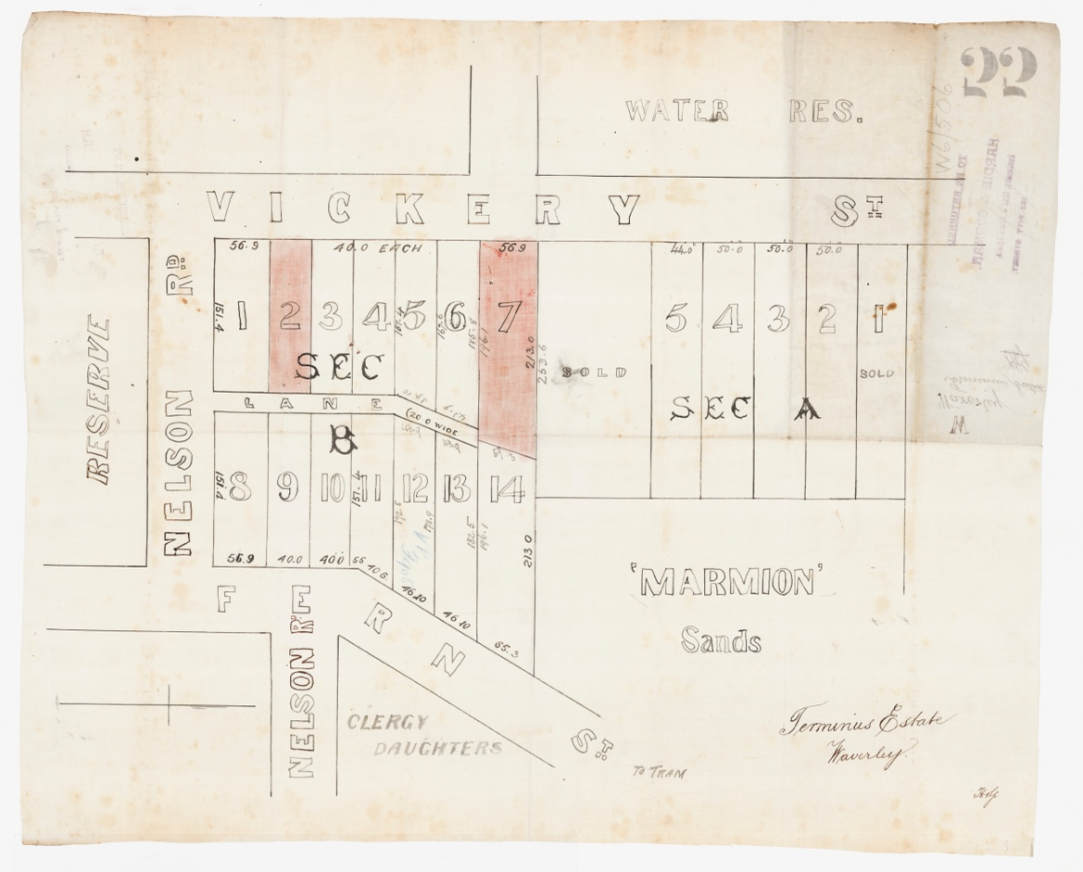
Image year | Undated | Image by | State Library of New South Wales | Image copyright holder

Image caption | 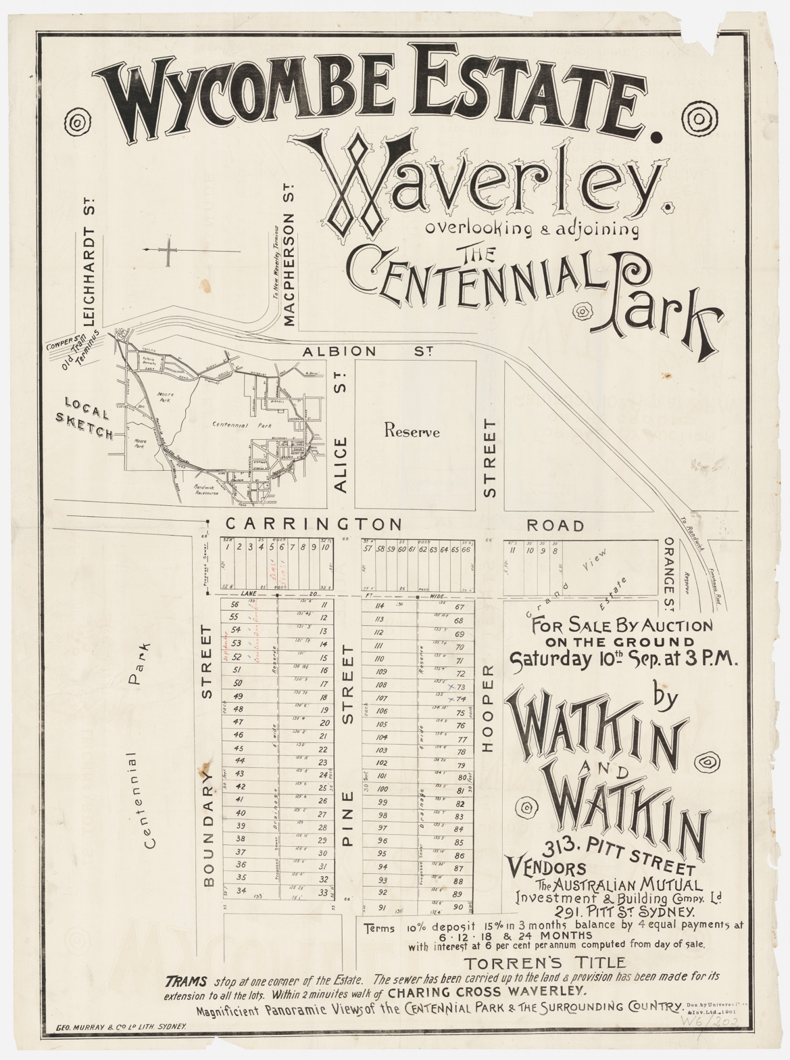
Image year | Undated | Image by | State Library of New South Wales | Image copyright holder

Image caption | 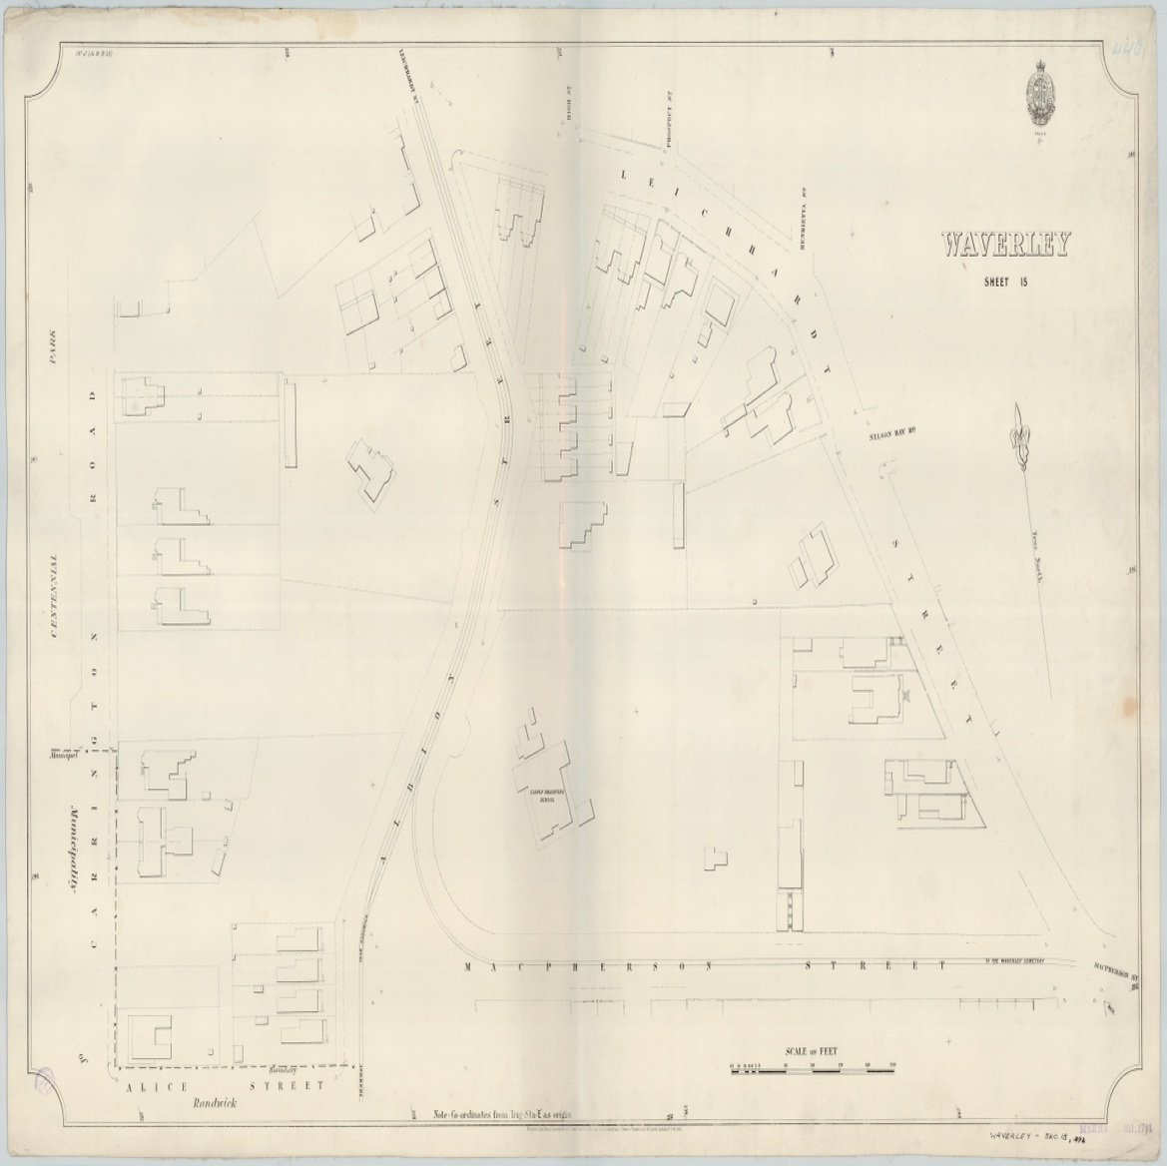
Image year | 1892 | Image by | State Library of New South Wales | Image copyright holder

Image caption | 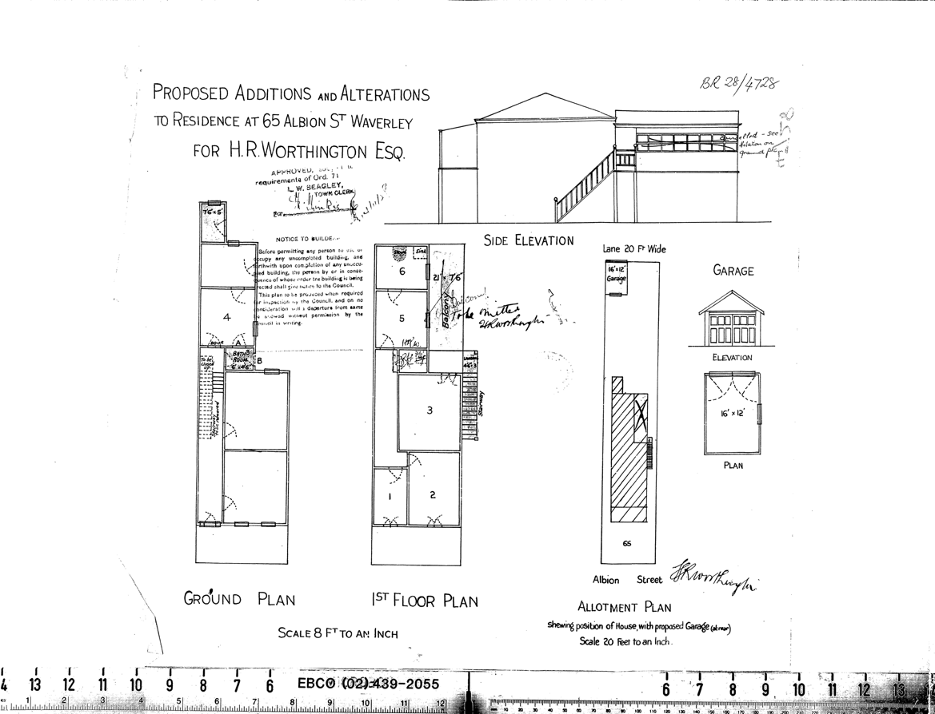
Image year | 1928 | Image by | Waverley Council | Image copyright holder

Image caption | 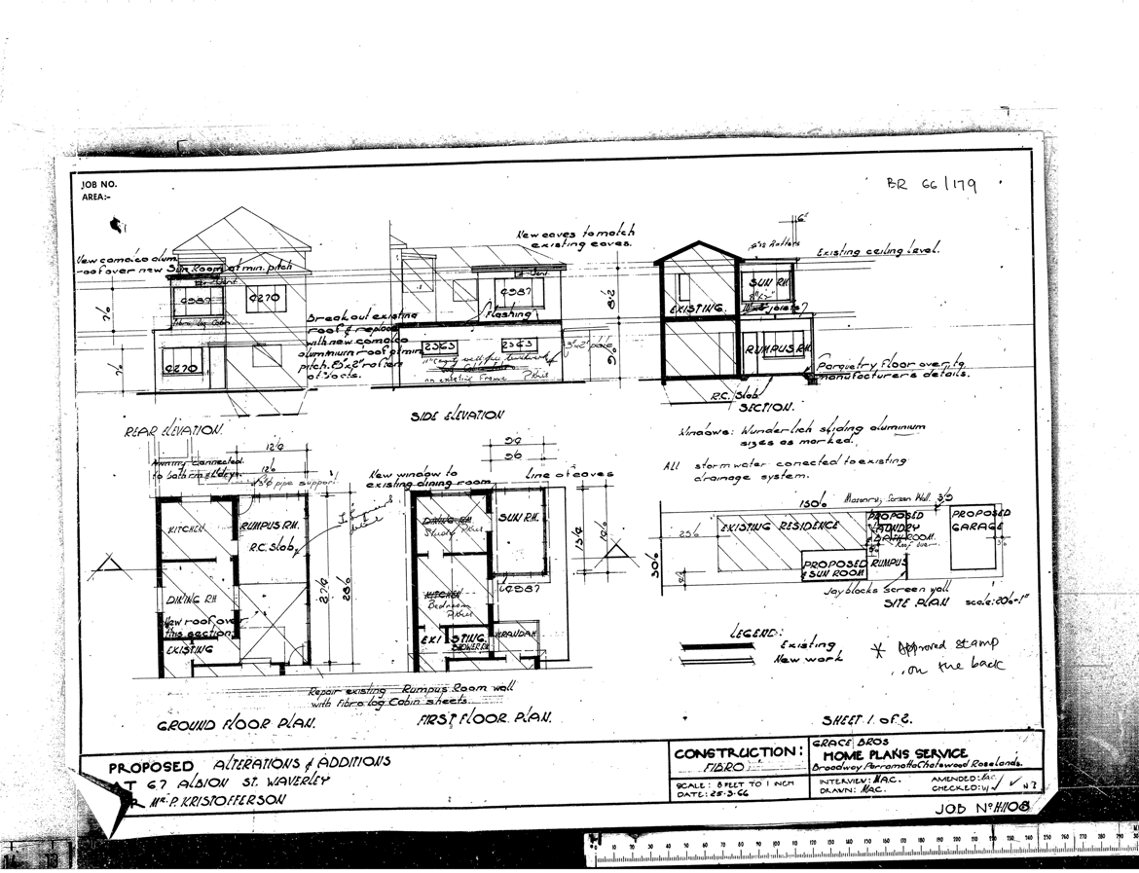
Image year | 1966 | Image by | Waverley Council | Image copyright holder

